#### MoveCritic – Wearable Full Body Motion Tracking System (WFBMTS) Technical Design Document

Contents

1. Overview 1

2. System Architecture 1

2.1 Body Tracking Elements (BTEs) 1

2.2 Body Tracking Controller (BTC) 2

3. Landmark Body Locations for BTE’s 2

4. Technical Specifications 2

4.1 Body Tracking Elements Technical Specification 2

4.2 Body Tracking Controller Technical Specification 3

6. Body Tracking Element (BTE) Calibration 3

7. Body Tracking Element Prototype (V0.1) 4

7.1 BTE Prototype Table of Components 4

7.2 BTE Prototype (V0.1) RF Sub-system 5

8. References 6

9. Appendix 7

5.1 BTE Prototype Schematic 7

5.2 Exploded View of Early BTE Concept Design 8

## 1. Overview

The MoveCritic - Wearable Full Body Motion Tracking System (WFBMTS) is designed to provide comprehensive and precise full-body motion tracking for analysing form and posture during exercises, stretches, and movements, with a particular focus on aiding physiotherapy practices. The system comprises individual wearable motion tracking elements known as Body Tracking Elements (BTEs), strategically placed on various significant areas of the user's body (Body Landmarks) to enable full-body motion tracking. These BTEs are wireless, battery-powered devices utilising MEMS (Micro-Electro-Mechanical Systems) inertial measurement units to track attitude and motion. The system's central component is the Body Tracking Controller (BTC), which facilitates communication between the BTEs and an app running on an external smart device as well as acting as a case for storage and charging in-between uses (similar to the air pods (BTE’s), and the air pod case (BTC)).

## 2. System Architecture

The MoveCritic WFBMT Hardware system consists of the following key components:

[ BTEs ] <---- BLE ----> [ BTC ] <---- BLE ----> [ Smartphone App ]

### 2.1 Body Tracking Elements (BTEs)

* The BTEs are individual wearable devices equipped with MEMS inertial measurement units.
* They are strategically placed on various areas of the user's body to capture detailed motion data.
* Each BTE is wireless, battery-powered, and capable of Bluetooth Low Energy (BLE) communication.
* A BTE is required for each landmark body location.

### 2.2 Body Tracking Controller (BTC)

* The BTC serves as the central hub for the system.
* It receives motion data from all BTE devices via BLE communication.
* The BTC integrates a Bluetooth link to facilitate communication with a smartphone application.
* Additionally, the BTC acts as a storage case and charging station for all BTEs when they are not in use.

The complete system is comprised of a single BTC which can host a number (max number of landmark locations, TBC) of BTE’s.

## 3. Landmark Body Locations for BTE’s

This section will define all the required locations at which it must be possible to attach a Body Tracking Element (BTE’s). These locations must be carefully chosen to maximise useful data collection. A wide variety of exercises must be analysed to decide on all the required tracking points that are required.

All landmarks should be on the external facing side of the body (i.e. outside of the wrist etc…) to ensure no restriction of movement, easily mounted and to limit hindrance to communications due to human body signal attenuation.

## 4. Technical Specifications

### 4.1 Body Tracking Elements Technical Specification

The following is a set of requirements that defines the basic function of a single Body Tracking Element (BTE).

|  |  |  |
| --- | --- | --- |
| **Table 1: Body Tracking Element Technical Specification** | | |
| **Ref Number** | **Requirement** | **Expected/**  **Desirable** |
| **SEN** | **Sensing** |  |
| **BTE-SEN-01** | **Must** make use of 6-DoF MEMS Inertial Measurement Units (IMUs) incorporating accelerometers, gyroscopes in X, Y and Z body frame axes. | **Expected** |
| **BTE-SEN-02** | **Must** make use of low-cost devices with long manufacturing lifetimes and readily available. | **Expected** |
| **BTE-SEN-03** | **Could** make use of Magnetometers for additional sensing. Will require 9-DoF MEMs IMU’s. | **Desired** |
| **BTE-SEN-04** | **Should** use CoTS MEMs IMU’s with built in Motion Processing to reduce Algorithm development workload. Example: <https://invensense.tdk.com/wp-content/uploads/2016/06/DS-000189-ICM-20948-v1.3.pdf?ref_disty=digikey> | **Desired** |
| **BTE-SEN-05** | **Must** use low power sensors and not exceed the total sensor Power budget of 50mW. | **Expected** |
| **COM** | **Communication** |  |
| **BTE-COM-01** | **Must** use Bluetooth Low-Energy (BLE) for low power short range wireless communication to BTC. | **Expected** |
| **BTE-COM-02** | **Should** use a low-profile 2.4GHz antenna built into the PCB to reduce component costs. | **Desired** |
| **BTE-COM-03** | Antenna design **must** be capable of communicating effectively to the BTC at any of the body landmark locations without significant signal attenuation from human body. **Must** be verified through simulation. | **Expected** |
| **POW** | **Power** |  |
| **BTE-POW-01** | **Must** use low-cost, portable, and rechargeable Li-Po or Li-Ion batteries | **Expected** |
| **BTE-POW-02** | **Must** be able to provide power for a minimum of 2 hours of continuous operation between charges. | **Expected** |
| **BTE-POW-03** | **Should** be capable of wireless charging within the BTC. | **Desired** |
| **MEC** | **Mechanical Design** |  |
| **BTE-MEC-01** | The physical design **must** be a small, low-profile, and lightweight as possible and **must** in no way impede any kind of body movement. | **Expected** |
| **BTE-MEC-02** | **Must** have a sealed and rugged plastic outer casing to protect internal electronics from fluids and impacts | **Expected** |
| **BTE-MEC-03** | Given the user will have to wear multiple devices they **Must** be easily attachable/removeable. E.g. Use magnets to quickly attach to wearable bands or clothing. **Topic for discussion**. | **Expected** |

### 4.2 Body Tracking Controller Technical Specification

The following is a set of requirements that defines the basic function of the Body Tracking Controller (BTC).

|  |  |  |
| --- | --- | --- |
| **Table 2: Body Tracking Controller (BTC) Technical Specification** | | |
| **Ref Number** | **Requirement** | **Expected/**  **Desirable** |
| **PRO** | **Data Processing** |  |
| **BTC-PRO-01** | **Must** be capable of providing the computational power required to run real-time sensor fusion / motion inferences algorithms. | **Expected** |
| **COM** | **Communication** |  |
| **BTC-COM-01** | **Must** use Bluetooth Low-Energy (BLE) for low power short range wireless multi-channel communication to the maximum number of BTE’s. | **Expected** |
| **BTC-COM-02** | **Must** use Bluetooth Low-Energy (BLE) for low power short range wireless communication to smart phone device. | **Expected** |
| **POW** | **Power** |  |
| **BTC-POW-01** | **Must** provide wireless charging for all BTE’s. | **Expected** |
| **BTC-POW-02** | **Should** feature an internal battery capable of providing a full charge to all BTE’s when fully charged. This allows charging of BTE’s without an external power source. | **Desired** |
| **MEC** | **Mechanical Design** |  |
| **BTC-MEC-01** | **Must** featureindividual charging slots for each Body Tracking Element (BTE) with easily securable connection/fastening mechanism i.e. wireless charging and or magnetic connection. | **Expected** |
| **USR** | **User Indications** |  |
| **BTC-USR-01** | Each charging slot **should** be equipped with a dedicated indicator light to display the charging status of the corresponding BTE | **Expected** |

## 6. Body Tracking Element (BTE) Calibration

Calibration will be critical in determining accurate motion and attitude. Hopefully a one-time calibration will suffice for accelerometers and Gyroscopes. If 9-DoF IMU’s are used, then the magnetic environment will significantly affect results. This may require a more involved user calibration before use.

All BTE’s will require attitude (orientation) calibration in a fixed pose by the user before use. This can be very quick and easy to achieve. Pose will most likely be:

* Feet together
* Hands by sides
* Back straight
* Head up (eyes facing straight)

Attitude calibration can be triggered through app’s user interface. This would require calibration command to be sent from BTC to all active BTE’s.

## 7. Body Tracking Element Prototype (V0.1)

The BTE prototype is designed to act as a platform for the development of firmware and algorithms, thus contains components that should be excluded from the production design such as SWD connectors/USB2.0 connectors and JST battery connectors.

### 7.1 BTE Prototype Table of Components

The following is a complete list of components to be purchased for a single prototype BTE (V0.1).

|  |  |  |
| --- | --- | --- |
| **Table 3: Table of Components for BTE Prototype V0.1** | | |
| **Designator(s)** | **Description** | **Datasheet** |
| C1,C2,C3,C4,C5,C6,C8,C10,C20,C21,C25 | 0.1uF Cap 0201 0603 | <https://www.mouser.co.uk/datasheet/2/40/cx5r_KGM-3223198.pdf> |
| C7,C9,C11,C16,C17,C18,C19,C22,C24 | 4.7uF Cap 0201 0603 | <https://www.mouser.co.uk/datasheet/2/40/cx5r_KGM-3223198.pdf> |
| C12,C13 | 0.10pF Cap 0402 1005 | <https://www.mouser.co.uk/datasheet/2/40/C0GNP0_KGM-3216332.pdf> |
| C14 | 0.8pF Cap 0402 1005 | <https://www.mouser.co.uk/datasheet/2/447/KEM_C1121_CBR_AUTO-3316745.pdf> |
| C15 | 0.3pF Cap 0402 1005 | <https://www.mouser.co.uk/datasheet/2/281/1/GRM1555C1HR30BA01_01A-1983029.pdf> |
| C23 | 100pF Cap 0201 0603 | <https://www.mouser.co.uk/datasheet/2/40/KGM_X7R-3223212.pdf> |
| D1 | B5819W Diode (Bat Protect) | <https://www.mouser.co.uk/datasheet/2/258/B5817W_B5819W_SOD_123_-1816268.pdf> |
| D2 | Red Indicator LED | <https://www.we-online.com/components/products/datasheet/150040RS73240.pdf> |
| FLT1 | DLF162500LT-5028A1 (RF Low-pass filter) | <https://product.tdk.com/system/files/dam/doc/product/rf/rf/filter/catalog/rf_lpf_dlf162500lt-5028a1_en.pdf> |
| J1 | JST_PH_2.00mm (Bat Connector) | <https://www.jst-mfg.com/product/pdf/eng/ePH.pdf> |
| J3 | USB2.0_type_C Male | <https://www.mouser.co.uk/datasheet/2/837/Global_Connector_Technology_usb4105-3106202.pdf> |
| L1 | 10nH Ind 0402 1005 | <https://productfinder.pulseelectronics.com/api/open/part-attachments/datasheet/ASCH0010050510NJ> |
| L2 | 10uH Ind 0805_2012 | <https://www.mouser.co.uk/datasheet/2/396/Taiyo_Yuden_LSQ02_e-3370445.pdf> |
| L3 | 2.7nH Ind 0402 1005 | <https://www.mouser.co.uk/datasheet/2/281/1/JELF243B_0010-1699614.pdf> |
| R1,R2 | 1KΩ R 0603 1608 | <https://www.mouser.co.uk/datasheet/2/315/AOA0000C307-1149632.pdf> |
| R3,R4 | 5.1KΩ R 0402 1005 | <https://www.mouser.co.uk/datasheet/2/447/PYu_RP_51_RoHS_L_0-3071169.pdf> |
| R5 | 220Ω R 0201 0603 | <https://www.mouser.co.uk/datasheet/2/315/AOA0000C304-1149620.pdf> |
| U1 | STM32WB55CEU6 MCU | <https://www.mouser.co.uk/datasheet/2/389/dm00344191-1798909.pdf> |
| U2 | USBLC6-2P6 | <https://www.mouser.co.uk/datasheet/2/389/cd00050750-1796222.pdf> |
| U3 | MIC5365-3.3YD5 LDO | <https://www.mouser.co.uk/datasheet/2/268/mic5365-1082359.pdf> |
| U4 | ICM-20948 | <https://invensense.tdk.com/wp-content/uploads/2016/06/DS-000189-ICM-20948-v1.3.pdf?ref_disty=digikey> |
| U5 | MIC5365-1.8YD5 LDO | <https://www.mouser.co.uk/datasheet/2/268/mic5365-1082359.pdf> |
| X1 | 32KHz768 LS Crystal | <https://www.we-online.com/components/products/datasheet/830009678.pdf> |
| X2 | 32MHz HS Crystal | <https://www.mouser.co.uk/datasheet/2/741/LFXTAL061677Reel-1519358.pdf> |

### 7.2 BTE Prototype (V0.1) RF Sub-system

To enable Bluetooth LE communications to a BTC, the BTE design must incorporate a 2.4GHz antenna design.

#### 7.2.1 Bluetooth Transceiver

The V0.1 prototype uses a STM32WB MCU that has built in BLE support (additional transceiver ICs are NOT required).

ST provides a recommended impedance matching circuit for a 50Ω antenna input impedance.

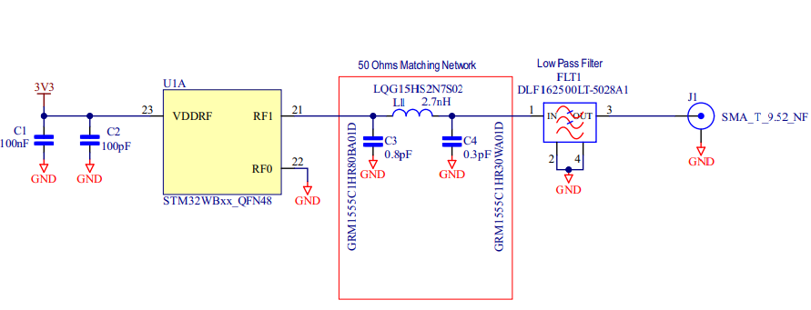

Figure 1: ST reference RF matching/filtering network.

#### 7.2.2 Antenna Design

V0.1 includes a compact 2.4GHz meandering inverted-F PCB antenna design from Texas Instruments [1]. TI indicates that the design should be optimised for an input impedance of 50Ω.

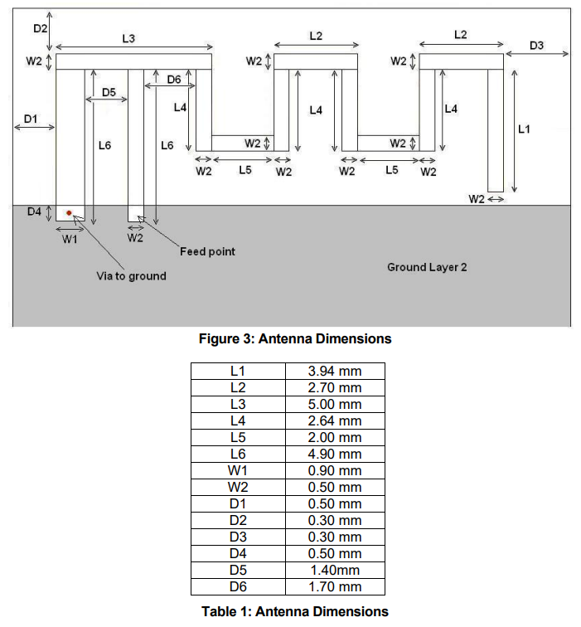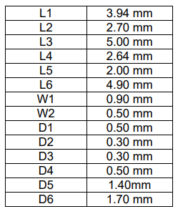

Figure 2: TI 2.4GHz MIFA Design Dimensions [1]

Note: The via between the surface copper and the ground plane must be back drilled in a 4-layer board design (up to the ground plane on layer 2), to prevent stubs effecting impedances.

#### 7.2.3 Transmission Line

The input impedance of the TI MIFA design is 50Ω. Using PCBWay’s 4-layer PCB stack up, gives a recommended 50Ω impedance track width of 0.17mm.

## 8. References

1. <https://www.ti.com/lit/an/swra117d/swra117d.pdf?ts=1708163712745&ref_url=https%253A%252F%252Fwww.google.com%252F>

## 9. Appendix

### A diagram of a computer Description automatically generated5.1 BTE Prototype Schematic

### 5.2 Exploded View of Early BTE Concept Design

